Furniture Rental Form
Please fill in the order forms with the AMOUNT of your chosen items and send to us before October 9, 2021.
Contact person: Jing Wang
Tel: 022-60761191; 18222120732;
Email: 1024310862@qq.com
No. | Name | Picture | Size | Price/Whole Period(RMB) | Amount
1 | Folding chairs  (Black, white) | 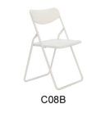 |  | 30
2 | The gourd chair | 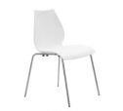 |  | 75
3 | Barstool | 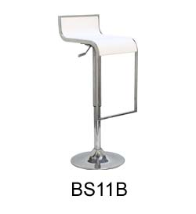 |  | 125
4 | Sofa chair | 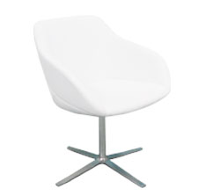 |  | 320
5 | Single person sofa | 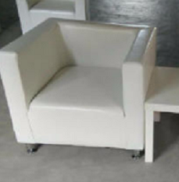 | 77*75*70cm | 300
6 | Glass table | 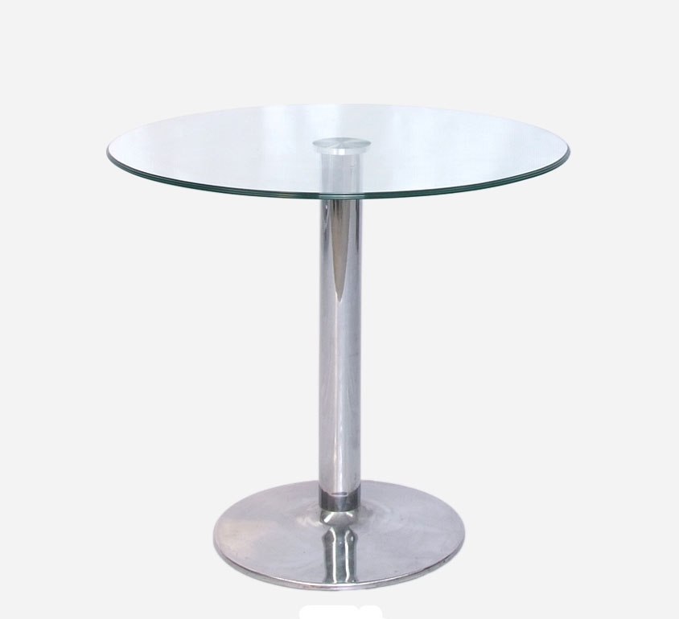 | Diameter 60 | 150
7 | Wood surface round table | 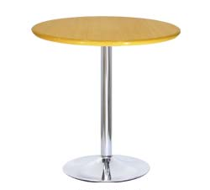 | Diameter 60 | 150
8 | Bar Table | 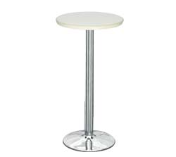 | Diameter 60 | 230
9 | Long table | 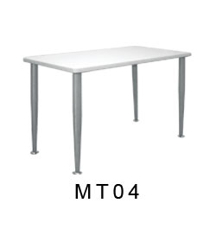 | 120*60*74cm | 230
10 | Tea table | 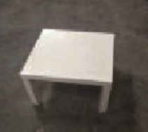 | 50*50cm | 230
11 | Glass coffee table | 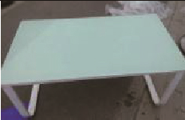 | 50*100cm | 450
12 | Glass high display case | 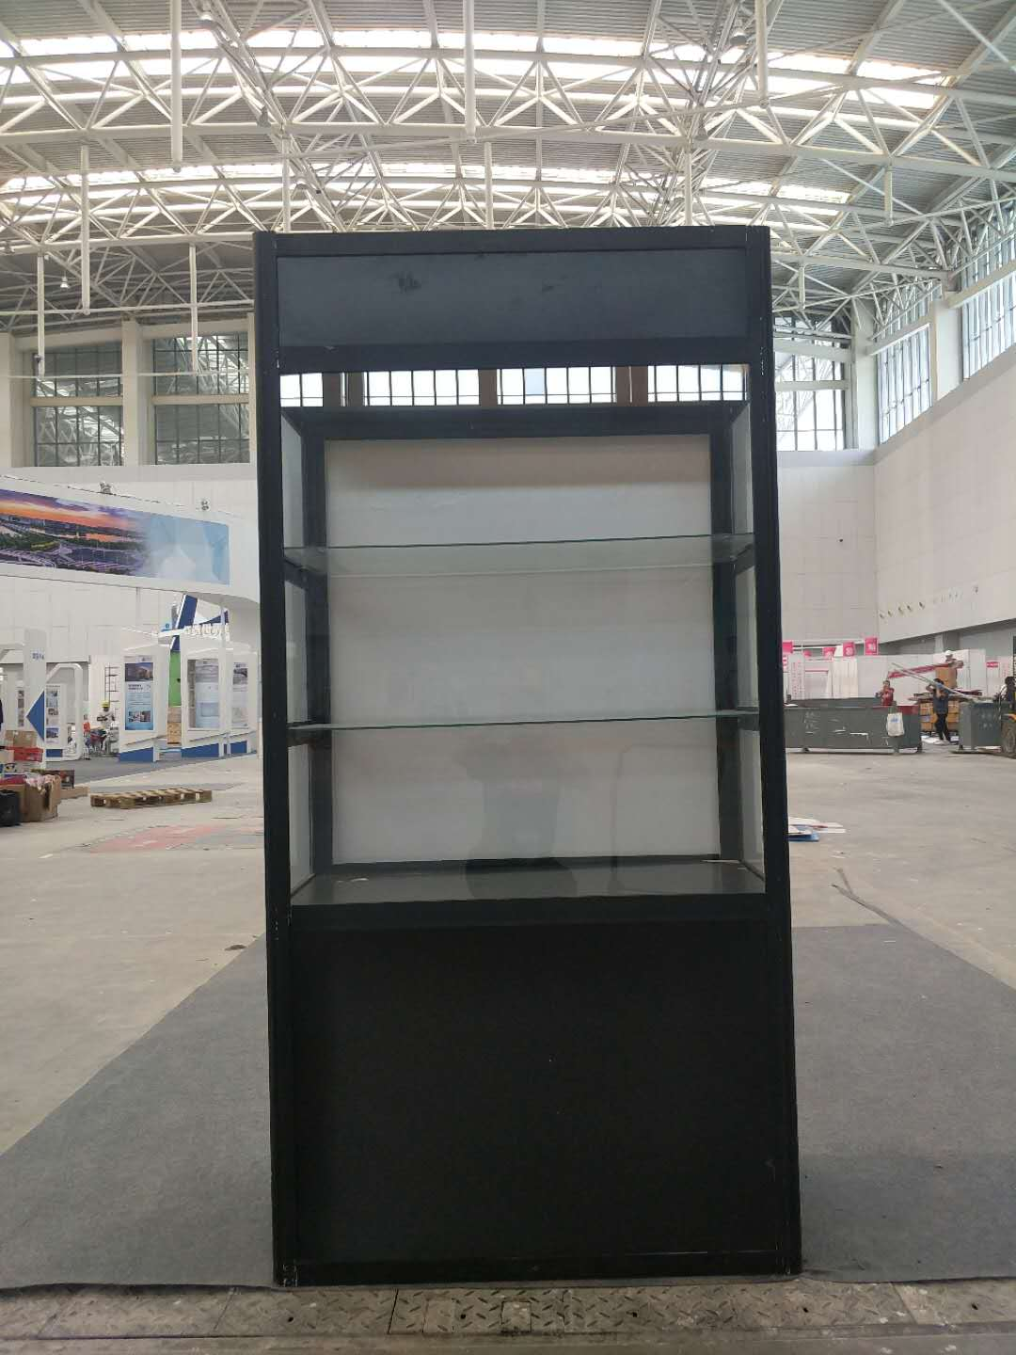 | 200*100*45cm | 600
13 | Small glass display case | 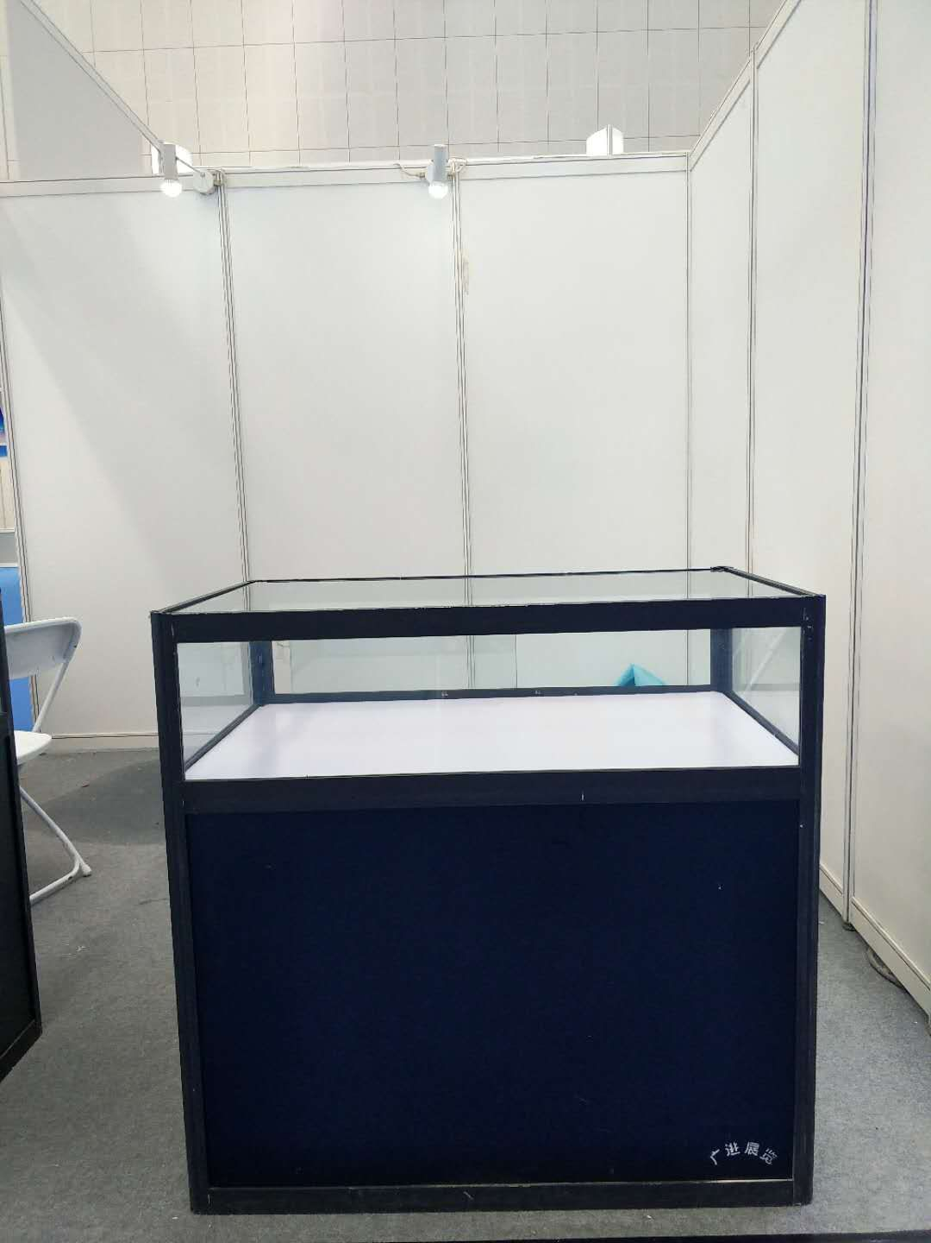 | 100*95*57cm | 460
14 | Water dispenser(With 2 barrels of water) | 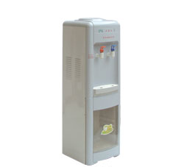 |  | 270
15 | TV | 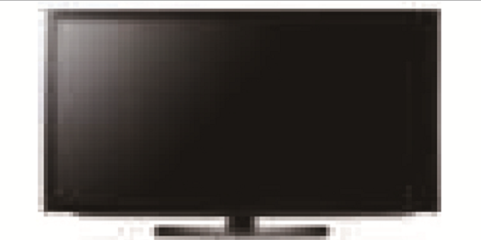 | 42/50/55 inch | 1500/2200/2600
16 | TV stents | 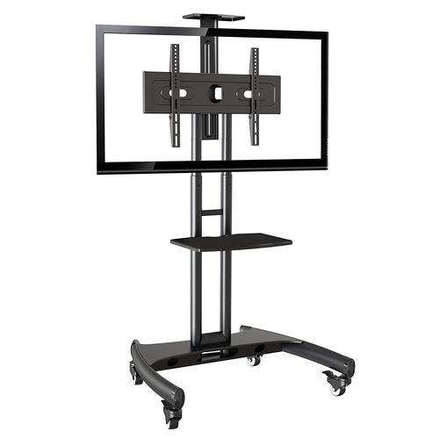 |  | 200
17 | Data frame | 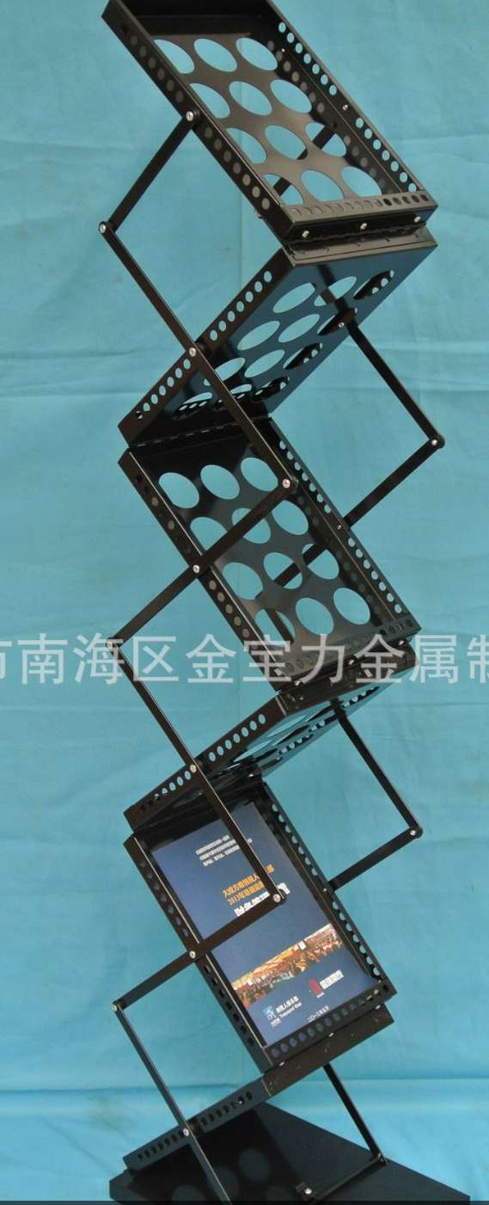 |  | 100
18 | Refrigerator | 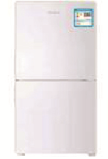 | 80*42*45cm | 800
19 | P2LED | 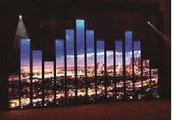 | 1㎡ | 1000
20 | Cardcase | 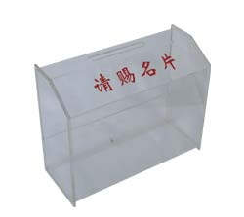 |  | 30

Your Company Name:
Booth Number: Contact Person:
Tel: We Chat:
Mobile:
Total Amount Of Payment:

